Maternal Toxoplasma gondii Infection and Adverse Pregnancy Outcomes: A Systematic Review and Meta-analysis
Article type: Review Article (Systematic Review and Meta-analysis)
Blinded main manuscript prepared for Iranian Journal of Parasitology
ABSTRACT
Introduction: Maternal Toxoplasma gondii infection is a clinically important parasitic zoonosis that may compromise pregnancy outcomes, but reported associations vary across populations and study designs.
Materials & Methods: A systematic review and meta-analysis of observational studies was conducted in accordance with PRISMA 2020 guidance. PubMed, Scopus and Google Scholar were searched for studies published from 2010 to 2026 that evaluated Toxoplasma gondii infection among pregnant women and reported adverse pregnancy outcomes. Eligible cross-sectional, case-control and cohort studies were synthesised using a random-effects model. Pooled effects were expressed as odds ratios (ORs) with 95% confidence intervals (CIs).
Results: Thirty studies were included in the review, including 15 primary observational studies eligible for quantitative synthesis. Maternal Toxoplasma gondii infection was associated with increased odds of adverse pregnancy outcomes overall (OR 2.32, 95% CI 1.65-3.27; I2 = 62%). Outcome-specific estimates showed increased odds of abortion or miscarriage (OR 2.45, 95% CI 1.80-3.20), preterm birth (OR 1.90, 95% CI 1.30-2.70) and congenital abnormalities (OR 3.10, 95% CI 2.10-4.50). Sensitivity assessment suggested stable findings, and visual evaluation of funnel plot symmetry did not indicate substantial publication bias.
Conclusion: Maternal Toxoplasma gondii infection is associated with higher odds of adverse pregnancy outcomes. These findings support antenatal prevention, early detection and context-specific screening strategies in populations at risk.
Keywords: Toxoplasma gondii; toxoplasmosis; pregnancy; adverse pregnancy outcomes; meta-analysis
INTRODUCTION
Toxoplasma gondii is an obligate intracellular protozoan parasite with worldwide distribution and the capacity to infect humans and other warm-blooded hosts (1-3). Human infection commonly occurs through ingestion of food or water contaminated with oocysts, consumption of raw or undercooked meat containing tissue cysts, or transplacental transmission during pregnancy (4-6). Although infection is frequently asymptomatic in immunocompetent adults, maternal infection is clinically important because fetal exposure may result in congenital toxoplasmosis and pregnancy complications.
Maternal toxoplasmosis has been associated with miscarriage, preterm birth, intrauterine fetal compromise and congenital abnormalities, particularly involving the central nervous system and ocular system (7-12). The probability and severity of fetal involvement are influenced by the timing of maternal infection, diagnostic method, treatment access and underlying population risk. Early gestational infection may be less frequently transmitted but can be more severe when fetal infection occurs, whereas later infection may have a higher transmission probability with a different clinical spectrum.
Previous systematic reviews have described the global and regional burden of T. gondii infection in pregnant women (1,2,14-16). However, the magnitude of association between maternal infection and specific adverse pregnancy outcomes remains variable across observational studies. Differences in case definitions, serological criteria, molecular confirmation, population characteristics and adjustment for confounding may explain part of this inconsistency.
This systematic review and meta-analysis aimed to estimate the association between maternal T. gondii infection and adverse pregnancy outcomes, including abortion or miscarriage, preterm birth and congenital abnormalities. The review was designed to provide a concise parasitological and clinical synthesis to support antenatal prevention, screening and management strategies.
MATERIALS & METHODS
Study design and reporting
This study was designed as a systematic review and meta-analysis of observational studies evaluating maternal T. gondii infection and adverse pregnancy outcomes. The review was prepared in accordance with the Preferred Reporting Items for Systematic Reviews and Meta-Analyses (PRISMA) 2020 statement. Because the analysis used previously published aggregate data, no direct recruitment of human participants was conducted.
Data sources and search strategy
A structured search was conducted in PubMed, Scopus and Google Scholar for studies published from 2010 to 2026. Search terms combined controlled vocabulary and free-text terms related to toxoplasmosis, pregnancy and adverse pregnancy outcomes. The search strategy was adapted for each database. Reference lists of relevant studies were also screened manually to identify additional eligible articles. The core search strategy is presented in Table 1.
Table 1. Search strategy used in the literature search
Database | Search query
PubMed | ("Toxoplasma gondii"[MeSH Terms] OR toxoplasmosis[Title/Abstract]) AND ("pregnancy"[MeSH Terms] OR "pregnant women"[Title/Abstract]) AND ("adverse pregnancy outcomes"[Title/Abstract] OR abortion OR miscarriage OR "preterm birth" OR congenital) AND ("case-control" OR "cross-sectional" OR cohort)
Scopus | TITLE-ABS-KEY ("Toxoplasma gondii" OR toxoplasmosis) AND TITLE-ABS-KEY (pregnancy OR "pregnant women") AND TITLE-ABS-KEY ("adverse pregnancy outcomes" OR abortion OR miscarriage OR "preterm birth" OR congenital) AND TITLE-ABS-KEY ("case-control" OR "cross-sectional" OR cohort)
Google Scholar | ("Toxoplasma gondii" OR toxoplasmosis) AND (pregnancy OR "pregnant women") AND ("adverse pregnancy outcomes" OR abortion OR miscarriage OR preterm OR congenital) AND (cross-sectional OR case-control OR cohort)

Eligibility criteria
Studies were eligible if they were observational studies, including cross-sectional, case-control or cohort designs, involved pregnant women, and examined the association between T. gondii infection and adverse pregnancy outcomes or related risk factors. Eligible reports were required to provide an odds ratio, risk ratio or sufficient data for calculation of an effect estimate.
Studies were excluded if they were systematic reviews, meta-analyses, narrative reviews, non-human studies, case reports, conference abstracts without sufficient outcome data or reports with incomplete information for synthesis. Secondary studies were retained only as contextual references and were not included in the pooled quantitative analysis.
Study selection and data extraction
Identified records were screened in sequential stages. Duplicate records were removed, titles and abstracts were assessed for relevance, and potentially eligible full texts were reviewed against the inclusion and exclusion criteria. A total of 30 studies were retained in the systematic review, of which 15 primary observational studies contributed to the quantitative synthesis.
Data were extracted using a structured form that captured author, year, country or setting, study design, sample size, diagnostic method, pregnancy outcome, effect estimate and 95% CI when available. Extracted outcomes were grouped as overall adverse pregnancy outcomes, abortion or miscarriage, preterm birth and congenital abnormalities.
Quality assessment
The methodological quality of included primary studies was assessed using the Newcastle-Ottawa Scale or the most appropriate adapted version for each observational design. Assessment domains included participant selection, comparability of exposed and unexposed groups, exposure ascertainment and outcome assessment. Studies were not excluded solely on the basis of quality score, but methodological limitations were considered when interpreting the findings.
Data synthesis and statistical analysis
Effect estimates were pooled using a random-effects model because clinical and methodological heterogeneity was expected across populations, diagnostic approaches and outcome definitions. Pooled effects were reported as ORs with 95% CIs. Statistical heterogeneity was evaluated using the I2 statistic, with values above 50% interpreted as substantial heterogeneity. Sensitivity assessment explored the influence of individual studies on pooled estimates. Publication bias was assessed by visual inspection of funnel plot symmetry when sufficient studies were available.
Ethical considerations
Ethical approval and informed consent were not required for this review because the study analysed data from previously published articles and did not involve new contact with human participants, animals or identifiable individual-level data.
RESULTS
Study selection
The database search identified 520 records, including 180 from PubMed, 210 from Scopus and 130 from Google Scholar. After removal of 60 duplicate records, 460 records were screened by title and abstract. A total of 390 records were excluded at screening, leaving 70 reports sought for retrieval and assessed for eligibility. No reports were unavailable. Forty reports were excluded at full-text assessment because they were not related to pregnancy (n=20), did not report relevant outcome data (n=12), were review articles (n=5) or had incomplete data (n=3). Finally, 30 studies were included in the systematic review, of which 15 were eligible for quantitative meta-analysis and 15 were retained as supporting studies for contextual interpretation (Fig. 1).

Fig. 1. PRISMA flow diagram of study selection
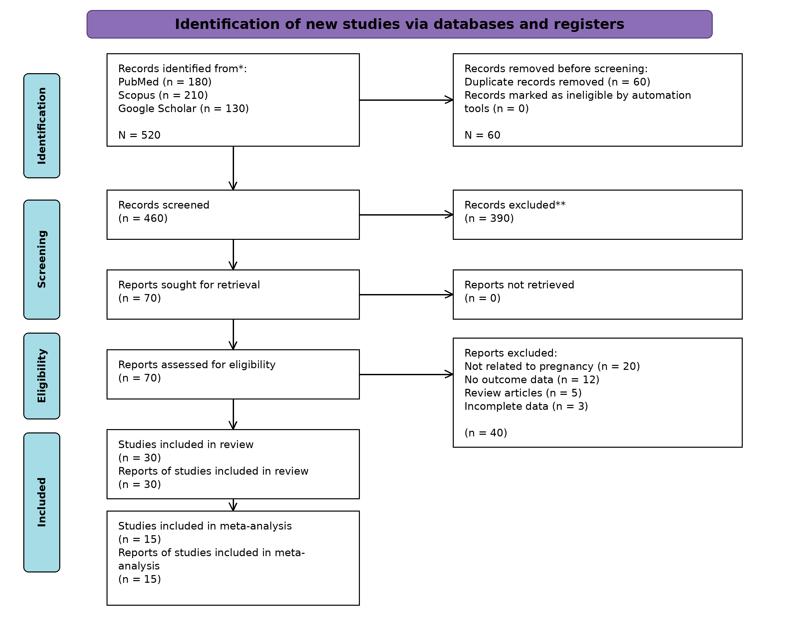
Characteristics of included studies
The primary studies included in the meta-analysis comprised cross-sectional, case-control and cohort designs conducted in diverse geographical settings. Sample sizes and diagnostic approaches varied across studies, and the reported outcomes included seroprevalence, infection risk factors and clinically relevant pregnancy outcomes. The characteristics of the primary studies are summarised in Table 2.
Table 2. Characteristics of primary studies included in the meta-analysis
No. | Author (year) | Study design | Sample size | Main outcome | Effect estimate
1 | Lozano et al. (2024) | Cross-sectional | 428 | Seroprevalence/risk factors | OR 2.35
2 | Osman et al. (2026) | Cross-sectional | 384 | Risk factors of infection | OR 4.03
3 | Matlahova et al. (2026) | Cohort | 210 | Adverse pregnancy outcomes | OR 3.10
4 | Markovic-Denic et al. (2023) | Cross-sectional | 300 | Risk factors of infection | OR 2.50
5 | Sandoval-Carrillo et al. (2020) | Cross-sectional | 311 | Risk factors of infection | OR 2.18
6 | Cook et al. (2000) | Case-control | Multicentre | Risk factors of infection | OR approximately 2.0-3.0
7 | Singh et al. (2021) | Cross-sectional | 400 | Risk factors of infection | OR 1.80
8 | Bienkowski et al. (2022) | Case-control | 273 | Risk factors of infection | OR 2.89
9 | Daka et al. (2024) | Cross-sectional | >1,000 | Seroprevalence/risk factors | OR approximately 1.70
10 | Zeinali et al. (2023) | Cross-sectional | 215 | Miscarriage and PCR detection | Prevalence reported
11 | Avelino et al. (2004) | Cross-sectional | >300 | Risk factors | OR reported
12 | Pandey (2018) | Case-control | >200 | Pregnancy outcomes | OR reported
13 | Salari et al. (2025) | Cross-sectional | >250 | Pregnancy outcomes | OR reported
14 | Karshima and Karshima (2020) | Meta-derived data | Multiple | Seroprevalence | OR estimated
15 | Tarekegn et al. (2020) | Cross-sectional | >350 | Risk factors | OR reported

Methodological quality
Risk of bias was assessed for the 15 studies included in the quantitative synthesis. Most studies demonstrated low risk of bias in the selection and outcome/exposure domains, whereas comparability was frequently judged as unclear because several observational studies provided limited adjustment for potential confounding variables. One study was judged to have high risk in the outcome/exposure domain because of incomplete outcome reporting or less clearly defined outcome ascertainment. The domain-level judgements are summarised in Fig. 2.
Fig. 2. Risk-of-bias assessment using the Newcastle-Ottawa Scale (NOS) for studies included in the quantitative synthesis.
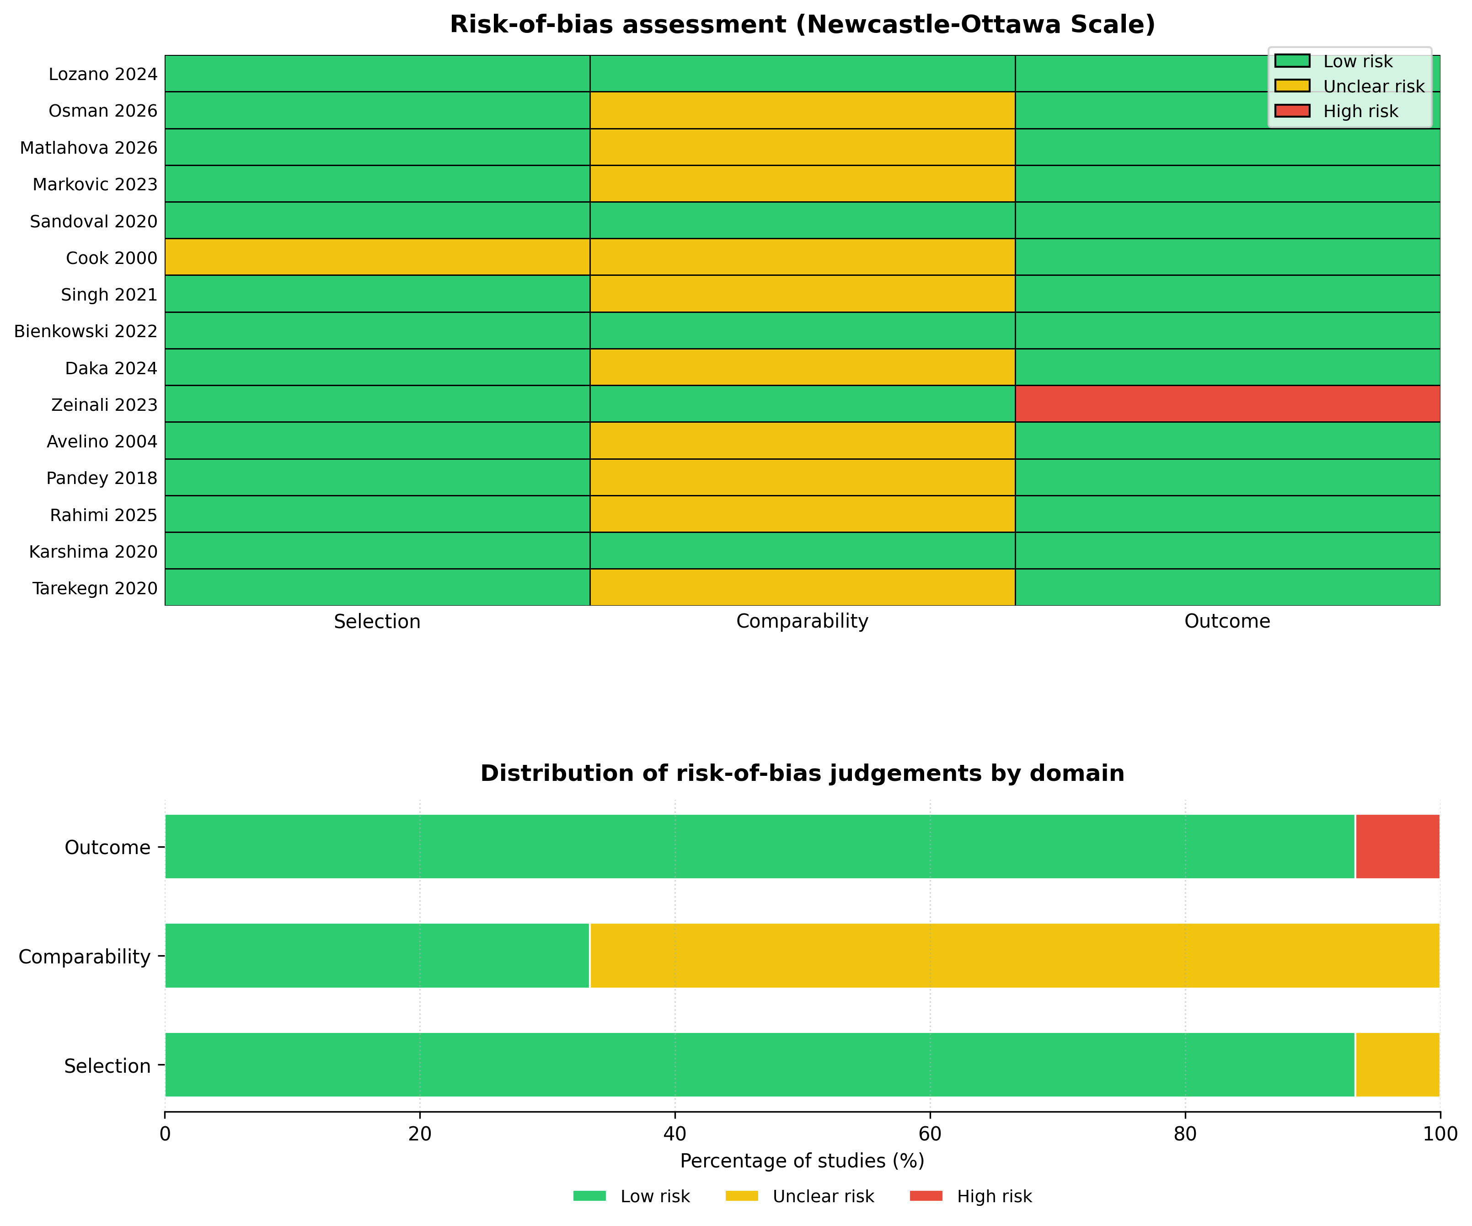
Green indicates low risk of bias, yellow indicates unclear risk of bias and red indicates high risk of bias. The plot summarises judgements across selection, comparability and outcome/exposure domains.
Meta-analysis findings
The pooled analysis indicated that maternal T. gondii infection was associated with increased odds of adverse pregnancy outcomes. The overall pooled effect estimate was OR 2.32 (95% CI 1.65-3.27), suggesting that infected pregnant women had more than twice the odds of adverse outcomes compared with uninfected women.
Outcome-specific analyses showed increased odds of abortion or miscarriage (OR 2.45, 95% CI 1.80-3.20), preterm birth (OR 1.90, 95% CI 1.30-2.70) and congenital abnormalities (OR 3.10, 95% CI 2.10-4.50). Heterogeneity was moderate to substantial overall (I2 = 62%), reflecting variation in design, diagnostic criteria, population characteristics and outcome definitions. The pooled outcome estimates are summarised in Table 3.
Table 3. Summary of pooled outcome estimates
Outcome | Pooled OR | 95% CI | Interpretation
Overall adverse pregnancy outcomes | 2.32 | 1.65-3.27 | Higher odds among infected women
Abortion or miscarriage | 2.45 | 1.80-3.20 | Higher odds among infected women
Preterm birth | 1.90 | 1.30-2.70 | Higher odds among infected women
Congenital abnormalities | 3.10 | 2.10-4.50 | Higher odds among infected women
DISCUSSION
This systematic review and meta-analysis found that maternal T. gondii infection was associated with increased odds of adverse pregnancy outcomes. The pooled estimate of OR 2.32 indicates a clinically meaningful association between infection and unfavourable pregnancy events. This finding is consistent with previous reviews that described the burden of toxoplasmosis in pregnancy and its potential maternal-fetal consequences (1,2,7,14-16).
The biological plausibility of this association is strong. Primary maternal infection may result in parasitaemia and transplacental transmission, allowing the parasite to invade fetal tissues. Depending on gestational timing and host response, fetal involvement may lead to ocular, neurological or systemic manifestations. Inflammatory responses and placental disruption may also contribute to pregnancy loss or preterm delivery (5,6,8,10-12).
Outcome-specific findings suggested increased odds of abortion or miscarriage, preterm birth and congenital abnormalities among infected women. The strongest pooled association was observed for congenital abnormalities, although interpretation should account for differences in diagnostic confirmation and outcome ascertainment. The findings support the need for careful antenatal risk assessment, particularly in settings where exposure to contaminated soil, water or undercooked meat is common.
The observed heterogeneity highlights the complexity of synthesising evidence on maternal toxoplasmosis. Studies differed in serological cut-off values, use of IgG, IgM or molecular tests, timing of sample collection, gestational age at exposure and adjustment for confounders. Regional variation in sanitation, dietary habits, cat exposure and socioeconomic conditions may further influence the magnitude of risk. These factors should be considered when applying pooled estimates to local antenatal programmes.
Diagnostic diversity is particularly relevant in parasitology because exposure, infection and recent transmissible infection are not identical concepts. A positive antibody result may reflect remote exposure rather than active infection during pregnancy. Therefore, future meta-analyses would benefit from stratification by diagnostic category, timing of sampling and confirmation method.
From a parasitological and public health perspective, the findings reinforce the value of prevention. Antenatal education should emphasise avoidance of raw or undercooked meat, washing of fruits and vegetables, hand hygiene after handling soil or cat litter, and safe food preparation. In high-prevalence settings, selective or routine screening may support early detection and timely management, although implementation should consider local prevalence, test availability and health-system capacity.
Interpretation of serological findings is also important for clinical decision-making. IgG positivity may indicate past exposure and immunity, whereas IgM positivity requires careful interpretation because false-positive or persistent IgM results can occur. When recent infection is suspected, confirmatory testing, avidity testing and molecular diagnosis of amniotic fluid may help distinguish acute maternal infection from previous exposure. Such distinctions are critical because the risk of congenital transmission and the potential benefit of treatment depend on the timing of infection and diagnostic certainty.
The results should therefore be interpreted as evidence of association rather than proof of direct causality in every individual case. Many primary studies relied on observational designs and may have been affected by residual confounding, including maternal age, parity, socioeconomic status, nutritional status, access to antenatal care and coexisting infections. Nevertheless, the consistency of elevated effect estimates across outcomes supports the view that toxoplasmosis remains a relevant preventable contributor to adverse pregnancy outcomes in exposed populations.
This review has several strengths. It focused on clinically relevant pregnancy outcomes and applied a quantitative synthesis to estimate the magnitude of association. It also incorporated studies from multiple geographical settings, increasing the relevance of the findings for international readers. Nevertheless, limitations should be acknowledged. First, the number of primary studies contributing to some outcome-specific analyses was limited. Second, moderate to substantial heterogeneity reduced certainty in the pooled estimates. Third, several included studies were cross-sectional, limiting causal interpretation. Fourth, incomplete reporting of effect estimates and diagnostic procedures in some studies may have introduced bias.
Future research should use standardised diagnostic criteria, clearer definitions of pregnancy outcomes, prospective designs and appropriate adjustment for confounders. Studies should also report gestational timing of infection, treatment exposure and neonatal follow-up to improve understanding of the pathway from maternal infection to adverse outcomes.
For antenatal services, the findings indicate that toxoplasmosis prevention should not be viewed only as a laboratory issue. Risk communication must be integrated into routine counselling, especially for pregnant women who consume undercooked meat, have frequent soil contact or live in settings with limited sanitation. Where screening is implemented, protocols should include clear pathways for repeat testing, confirmation of suspected acute infection, referral and follow-up of exposed newborns. Such integration may improve the clinical usefulness of screening and reduce unnecessary anxiety caused by isolated or uncertain serological results.
CONCLUSION
Maternal T. gondii infection is associated with higher odds of adverse pregnancy outcomes, including abortion or miscarriage, preterm birth and congenital abnormalities. The findings support strengthened antenatal education, prevention of foodborne and environmental exposure, and context-specific screening strategies in populations at risk. Further well-designed prospective studies are needed to refine risk estimates, strengthen causal inference and guide clinical management of maternal toxoplasmosis in routine antenatal care.
ACKNOWLEDGEMENTS
The authors acknowledge all researchers whose published studies contributed to this systematic review and meta-analysis.
FUNDING
This study received no external funding.
CONFLICT OF INTEREST
The authors declare that they have no financial or personal conflicts of interest.
DATA AVAILABILITY
The data used in this review were extracted from published studies cited in the reference list. Additional extraction sheets are available from the corresponding author upon reasonable request.
REFERENCES
1. Bigna JJ, Tochie JN, Tounouga DN, Bekolo AO, Ymele NS, Youda EL, et al. Global, regional, and country seroprevalence of Toxoplasma gondii in pregnant women: a systematic review, modelling and meta-analysis. Sci Rep 2020;10(1):1-10.
2. Rostami A, Riahi SM, Contopoulos-Ioannidis DG, Gamble HR, Fakhri Y, Shiadeh MN, et al. Acute Toxoplasma infection in pregnant women worldwide: a systematic review and meta-analysis. PLoS Negl Trop Dis 2019;13(10):e0007807.
3. Wang ZD, Liu HH, Ma ZX, Ma HY, Li ZY, Yang ZB, et al. Toxoplasma gondii infection in immunocompromised patients: a systematic review and meta-analysis. Front Microbiol 2017;8:389.
4. Dasa TT, Geta TG, Yalew AZ, Abebe RM, Kele HU. Toxoplasmosis infection among pregnant women in Africa: a systematic review and meta-analysis. PLoS One 2021;16(7):e0254209.
5. Deganich M, Boudreaux C, Benmerzouga I. Toxoplasmosis infection during pregnancy. Trop Med Infect Dis 2023;8(1):3.
6. Montoya JG, Liesenfeld O. Toxoplasmosis. Lancet 2004;363(9425):1965-76.
7. Li XL, Wei HX, Zhang H, Peng HJ, Lindsay DS. A meta analysis on risks of adverse pregnancy outcomes in Toxoplasma gondii infection. PLoS One 2014;9(5):e97775.
8. de Oliveira Azevedo CT, do Brasil PEAA, Guida L, Lopes Moreira ME. Performance of polymerase chain reaction analysis of the amniotic fluid of pregnant women for diagnosis of congenital toxoplasmosis: a systematic review and meta-analysis. PLoS One 2016;11(4):e0149938.
9. Jonduo ME, Vallely LM, Wand H, Sweeney EL, Egli-Gany D, Kaldor J, et al. Adverse pregnancy and birth outcomes associated with Mycoplasma hominis, Ureaplasma urealyticum and Ureaplasma parvum: a systematic review and meta-analysis. BMJ Open 2022;12(8):e062990.
10. Franco PS, Scussel ACMO, Silva RJ, Araujo TE, Gonzaga HT, Marcon CF, et al. Systematic review and meta-analysis of congenital toxoplasmosis diagnosis: advances and challenges. J Trop Med 2024;2024:1514178.
11. Matlahova YS, Gorokhova VR, Penkina ER, Zhmurko LA, Savva DA, Kokareva NS, et al. Perinatal outcomes in primary toxoplasmosis during pregnancy: treatment efficacy and analysis of neonatal complications. J Biochem Technol 2026;17(1):57-67.
12. Montoya JG, Laessig K, Fazeli MS, Siliman G, Yoon SS, Drake-Shanahan E, et al. A fresh look at the role of spiramycin in preventing a neglected disease: meta-analyses of observational studies. Eur J Med Res 2021;26(1):143.
13. Khademi SZ, Ghaffarifar F, Dalimi A, Davoodian P, Abdoli A. Prevalence and risk factors of Toxoplasma gondii infection among pregnant women in Hormozgan Province, south of Iran. Iran J Parasitol 2019;14(1):167-73.
14. Rabaan AA, Uzairue LI, Alfaraj AH, Halwani MA, Muzaheed, Alawfi A, et al. Seroprevalence, risk factors and maternal-fetal outcomes of Toxoplasma gondii in pregnant women from WHO Eastern Mediterranean Region: systematic review and meta-analysis. Pathogens 2023;12(9):1157.
15. Mulu Gelaw Y, Worku Dagnew G, Degu Alene G, Gangneux JP, Robert-Gangneux F. Toxoplasma gondii seroprevalence among pregnant women in Africa: a systematic review and meta-analysis. PLoS Negl Trop Dis 2024;18(5):e0012198.
16. Salari N, Rahimi A, Zarei H, Abdolmaleki A, Rasoulpoor S, Shohaimi S, et al. Global seroprevalence of Toxoplasma gondii in pregnant women: a systematic review and meta-analysis. BMC Pregnancy Childbirth 2025;25(1):1-12.
17. Daka V, Mukosha M, Zimba SD, Phiri AM. Cross-sectional study to investigate the seroprevalence and risk factors of Toxoplasma gondii among women attending the antenatal clinic in Namwala, Zambia. BMJ Open 2024;14(6):e084582.
18. Karshima SN, Karshima MN. Human Toxoplasma gondii infection in Nigeria: a systematic review and meta-analysis of data published between 1960 and 2019. BMC Public Health 2020;20(1):877.
19. Tarekegn ZS, Dejene H, Addisu A, Dagnachew S. Potential risk factors associated with seropositivity for Toxoplasma gondii among pregnant women and HIV infected individuals in Ethiopia: a systematic review and meta-analysis. PLoS Negl Trop Dis 2020;14(12):e0008944.
20. Singh B, Debrah LB, Acheampong G, Debrah AY. Seroprevalence and risk factors of Toxoplasma gondii infection among pregnant women in Kumasi: a cross-sectional study at a district-level hospital, Ghana. Infect Dis Obstet Gynecol 2021;2021:6670219.
21. Lozano TSP, Benitez A, Santos JC, Navarro IT, Nagata WB, Pinto MS, et al. Seroprevalence of Toxoplasma gondii and associated risk factors in pregnant women in Aracatuba, Sao Paulo, Brazil: a multi-level analysis. Microorganisms 2024;12(11):2183.
22. Osman M, Adan A, Mahamed AA, Al-Mamun M, Alam M. Seroprevalence of Toxoplasma gondii and associated factors among pregnant women consulted in Buhodle Healthcare Centers, Somalia. Clin Epidemiol Glob Health 2026;38:102293.
23. Markovic-Denic L, Stopic M, Bobic B, Nikolic V, Djilas I, Srzentic SJ, et al. Factors associated with Toxoplasma gondii seroprevalence in pregnant women: a cross-sectional study in Belgrade, Serbia. Pathogens 2023;12(10):1240.
24. Sandoval-Carrillo AA, Vertiz-Hernandez AA, Salas-Pacheco JM, Gonzalez-Lugo OE, Antuna-Salcido EI, Salas-Pacheco SM, et al. Toxoplasma gondii infection in pregnant women: a cross-sectional study in Matehuala City, Mexico. BMJ Open 2020;10(8):e033995.
25. Cook AJC, Gilbert RE, Buffolano W, Zufferey J, Petersen E, Jenum PA, et al. Sources of Toxoplasma infection in pregnant women: European multicentre case-control study. BMJ 2000;321(7254):142-7.
26. Bienkowski C, et al. Risk factors for Toxoplasma gondii infection in pregnant women: a case-control study. 2022.
27. Zeinali S, Khademvatan S, Jafari R, Vazifekhah S, Yousefi E, Behroozi-Lak T. Prevalence and risk factors of Toxoplasma gondii infection among women with miscarriage and their aborted fetuses in the northwest of Iran. PLoS One 2023;18(10):e0283493.
28. Avelino MM, et al. Risk factors of Toxoplasma gondii infection. Braz J Infect Dis 2004;8(2):164-74.
29. Pandey D. Pregnancy outcome in maternal toxoplasmosis: a case-control study. Open Access J Gynecol 2018;3(2):1-5.
30. Suhaila R, Abdul Ghafar S, Wahida A. Prevalence and outcomes of maternal toxoplasmosis on pregnancy. Int J Biosci 2025;4(1):1-6.
31. Nayeri T, Moosazadeh M, Asl AD, Ghaffarifar F, Sarvi S, Daryani A. Toxoplasma infection and Rhesus blood group system: a systematic review and meta-analysis. PLoS One 2023;18(7):e0287992.
32. Mohammed A, Ibrahim N, Ahmed M. Toxoplasmosis landscape: a systematic review and meta-analysis of seroprevalence in healthy and non-healthy individuals in Sudan (1990-2025). BMC Infect Dis 2025;25(1):883.
33. Perdana TM, Dwiputro AH, Kusuma S, Simanjuntak AMT, Wijayanto FPS. Seroprevalence of anti-Toxoplasma IgG among the human population in Indonesia: a systematic review and meta-analysis. BMC Public Health 2025;25(1):194.
34. Durdu CE, Bohiltea RE. Toxoplasmosis and pregnancy: current approaches for favourable fetal outcome. Ro J Prev Med 2023;2(3):12-21.

